Types of Clauses
# Source: AI Source: Provided by: [Data Path: Persons Table -> ID Column: 1, Name_En Column: Motasem Essam] -> From: [Chatgpt (GPT-4-turbo)] on [7/29/2025]
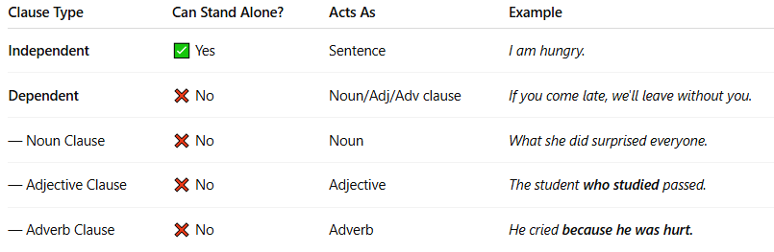

Clause Type | Can Stand Alone? | Acts As | Example
Independent | ✅ Yes | Sentence | I am hungry.
Dependent | ❌ No | Noun/Adj/Adv clause | If you come late, we'll leave without you.
— Noun Clause | ❌ No | Noun | What she did surprised everyone.
— Adjective Clause | ❌ No | Adjective | The student who studied passed.
— Adverb Clause | ❌ No | Adverb | He cried because he was hurt.

